**Docker Task -3**

**Task Description:**

Create a custom docker image for nginx and deploy it using docker compose, where the volume bind mount should be at /var/opt/nginx location. Push the created custom docker image to your docker-hub.

**Techstacks needs to be used :**

* AWS EC2
* Docker
* Docker Compose

STEP 1: Set Up Project Locally

Create a folder called **Docker-compose-nginx-hub-task** with these files:

Dockerfile

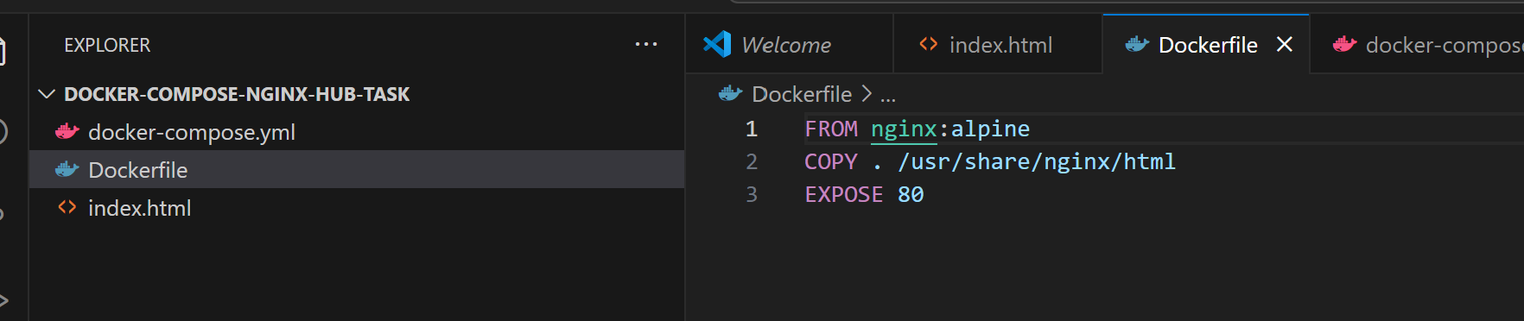 index.html

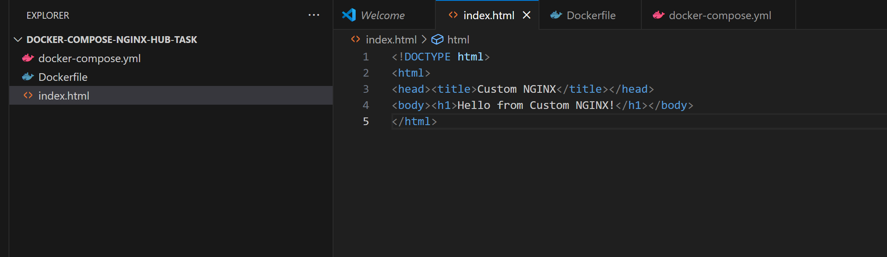

docker-compose.yml

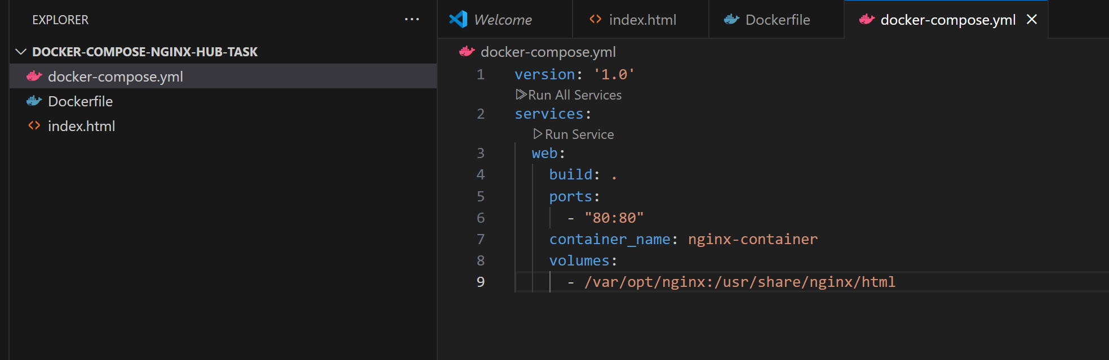

STEP 2: Build and Push the Image to Docker Hub

On your **local machine**:

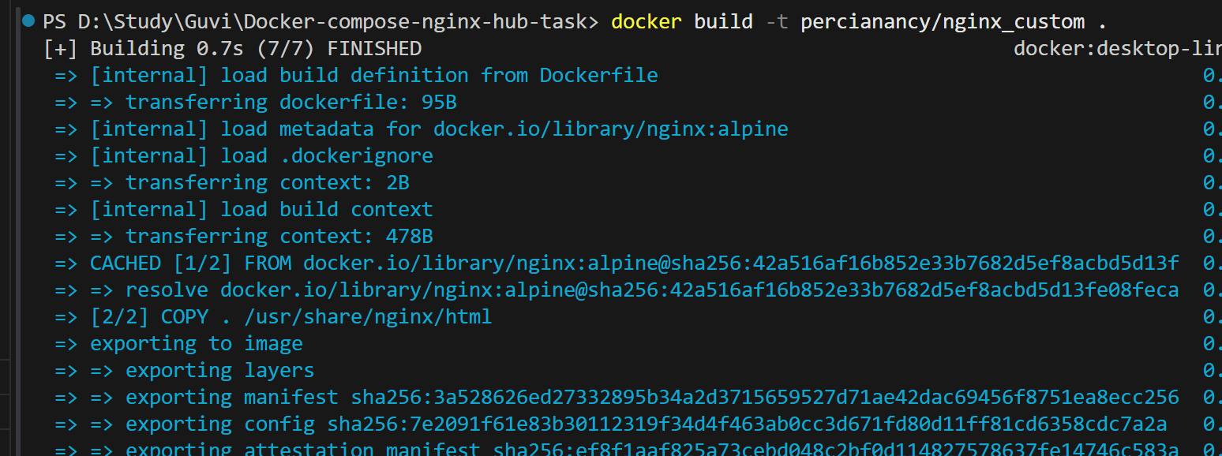

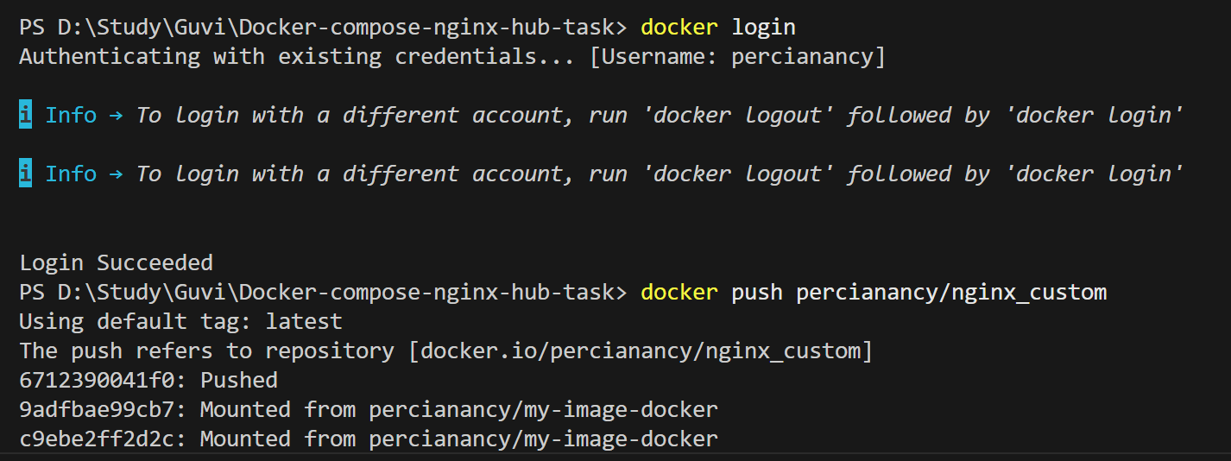

|  |
| --- |
| # Build the image  docker build -t percianancy/nginx-custom .  # Log in to Docker Hub  docker login  # Push the image  docker push percianancy/nginx-custom |

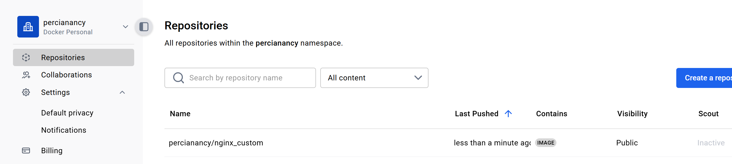

STEP 3: AWS EC2 Instance

|  |
| --- |
| SSH into EC2  ssh -i "docker-task.pem" [ec2-user@ec2-43-205-215-142.ap-south-1.compute.amazonaws.com](mailto:ec2-user@ec2-43-205-215-142.ap-south-1.compute.amazonaws.com)  Install Docker & Docker Compose  # Docker  sudo yum update -y  sudo yum install docker -y s  udo service docker start  sudo usermod -aG docker ec2-user  # Docker Compose  sudo curl -L "https://github.com/docker/compose/releases/download/v2.20.2/docker-compose-$(uname -s)-$(uname -m)" -o /usr/local/bin/docker-compose  sudo chmod +x /usr/local/bin/docker-compose |

STEP 4: Create Bind Mount Directory on EC2

|  |
| --- |
| sudo mkdir -p /var/opt/nginx  echo "<h1>Live from EC2 bind mount\!</h1>" | sudo tee /var/opt/nginx/index.html  <h1>Live from EC2 bind mount\!</h1> |

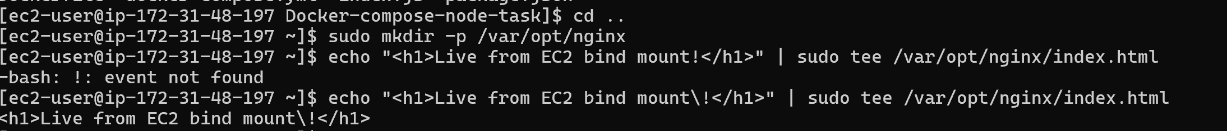

STEP 5: Transfer Project to EC2

From your **local machine**, run:

scp -i "docker-task.pem" -r "D:\Study\Guvi\Docker-compose-nginx-hub-task" [ec2-user@ec2-43-205-215-142.ap-south-1.compute.amazonaws.com:/home/ec2-user/](mailto:ec2-user@ec2-43-205-215-142.ap-south-1.compute.amazonaws.com:/home/ec2-user/)

Then on EC2:

cd ~/ Docker-compose-nginx-hub-task

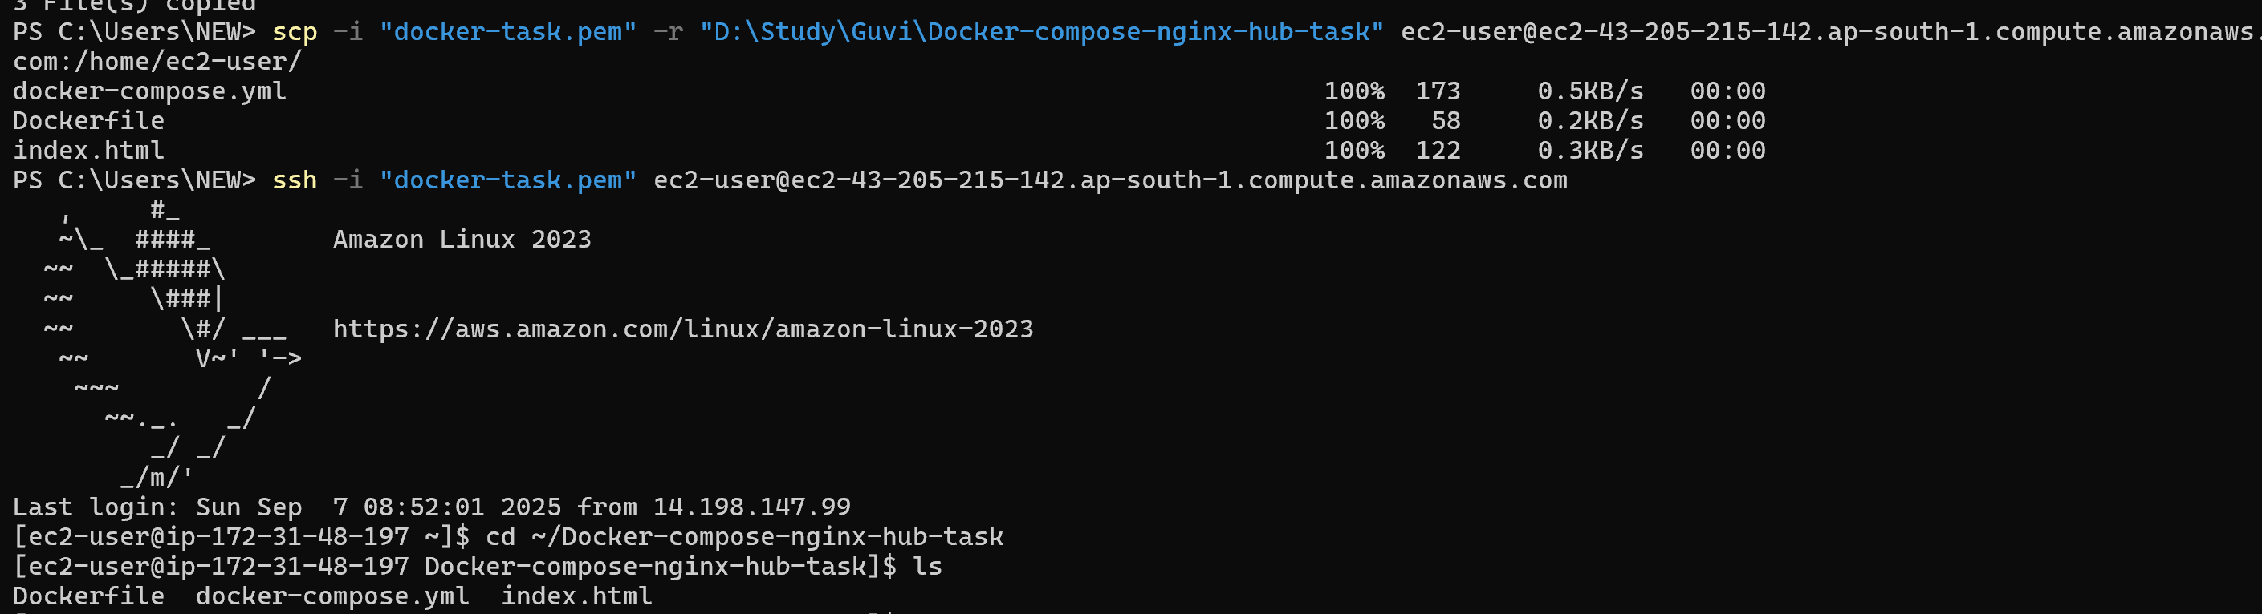

STEP 6: Deploy with Docker Compose

docker-compose up --build -d

